Karnataka Valuation & E-Registration (KAVERI - 2.0)
Government of Karnataka

Functional Requirement Specifications

For KAVERI 2.0
Department of Stamps & Registration
Government of Karnataka

Power of Attorney Authentication/Attestation

Prepared by
Centre for Smart Governance (CSG)
2nd Floor, TTMC Yeshwanthapura, BMTC Bus station
Bangalore – 560022

Contents
1. Document Scope 4
2. Overview 4
3. Overall functional flow 5
4. Functional Requirement Description 5
5. Process Description 12
6. Input and Output Validations 14
7. Integration with other systems/modules 15
8. Implications for MIS 15
9. Assumptions and Dependencies 15
10. Annexures 16

Acronyms
DEO | Data Entry Operator
FDA | First Division Assistant
PoA | Power of Attorney
SDA | Second Division Assistant
SRO | Kaveri 2 Sub-registrar Office

Revision History
Version | Date | Description | Modification
1.0 | 14-03-2023 | First Version
1.1 | 15-11-2024 | Revision 1 | This document consists of all the changes recommended by the department during the discussion.  The changes include the revised process flows of authentication/attestation and authentication/attestation and registration (in point 5) and fee structure.

Document Scope
This document is a Functional Requirement Specification (FRS) describing the functional features of the Authentication/Attestation of Power of Attorney in document registration. While a Power of Attorney can be registered in Kaveri 2.0 under the document registration module, the current FRS describes the functionality when a Power of Attorney is to be Authenticated/Attested or Authenticated/Attested and registered for presenting a document for registration.
There are 4 scenarios in Power of Attorney Authentication/Attestation which are mentioned below,
- Only Authentication: The POA is only authenticated by SRO.
- Only Attestation: The POA is only attested by SRO.
- Authentication and Registration: The POA is first authenticated and then registered by SRO.
- Attestation and Registration: The POS is first attested and then registered by SRO.

Overview
An executant who has executed the deed document and signed on the document but for unforeseen reasons, the executant will not be able to present the document in front of SR for registration, in such cases a PoA (Power of Attorney) will be executed referring that agent/attorney will be presenting the document on behalf of executant and such PoA’s must be Authenticated/Attested or Authenticated/Attested and Registered by the Sub-Registrar to allow the Attorney to present the document for the admission of registration.

Functional Requirement Description
The high-level flow of the process is shown for all four scenarios which are covered in the scope of this document.
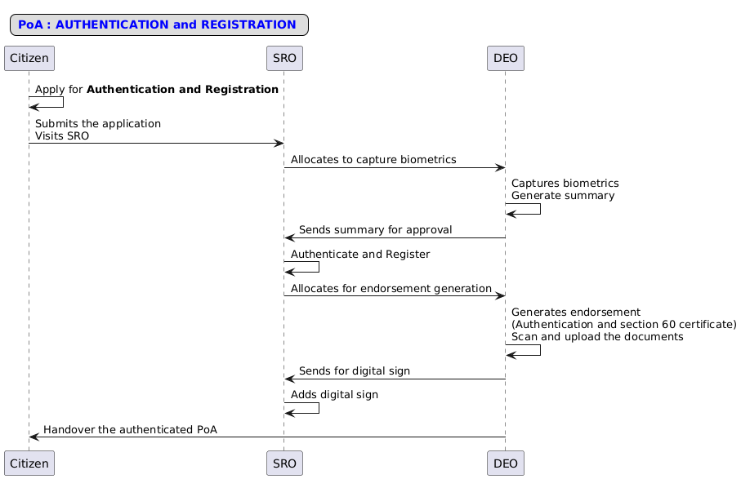
Figure 1: Interaction diagram of Authentication and Registration.
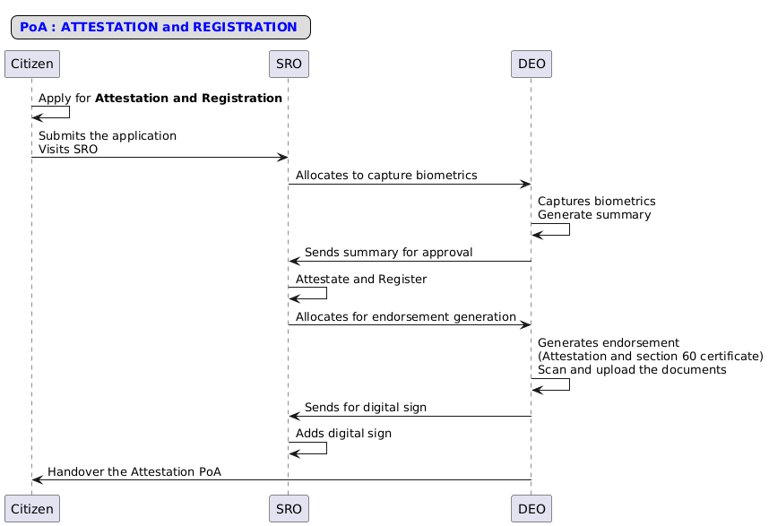
Figure 2: Interaction diagram of Attestation and Registration.
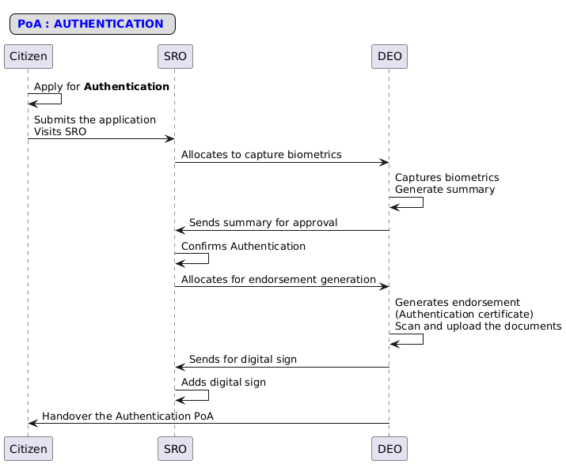
Figure 3: Interaction diagram of Authentication.
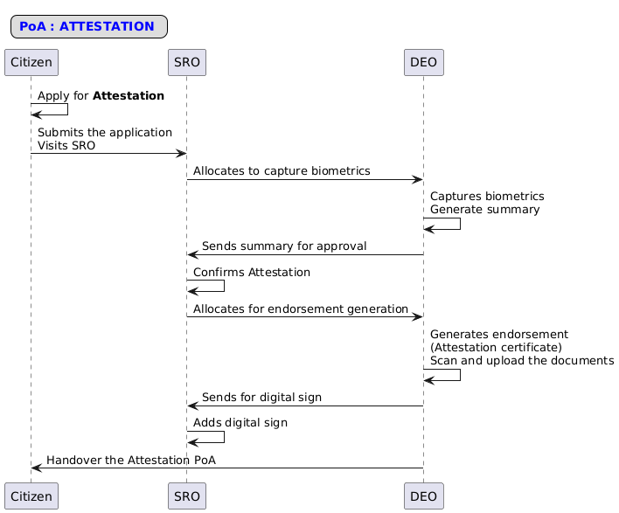
Figure 4: Interaction diagram of Attestation.

Workflow
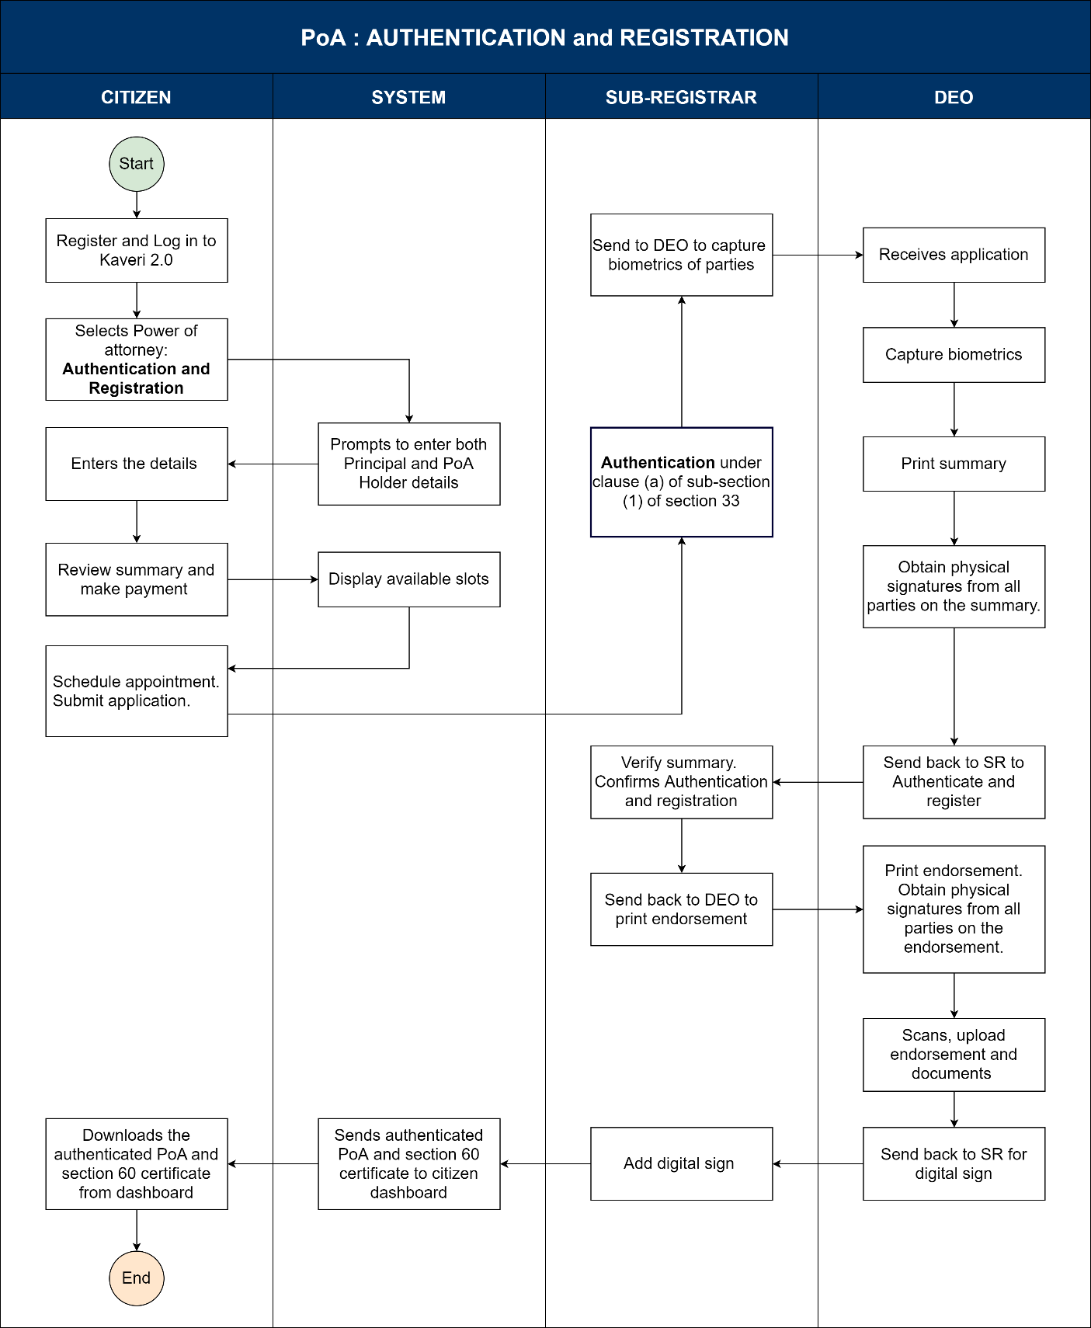
Figure 5: Activity diagram of Power of Attorney Authentication and Registration
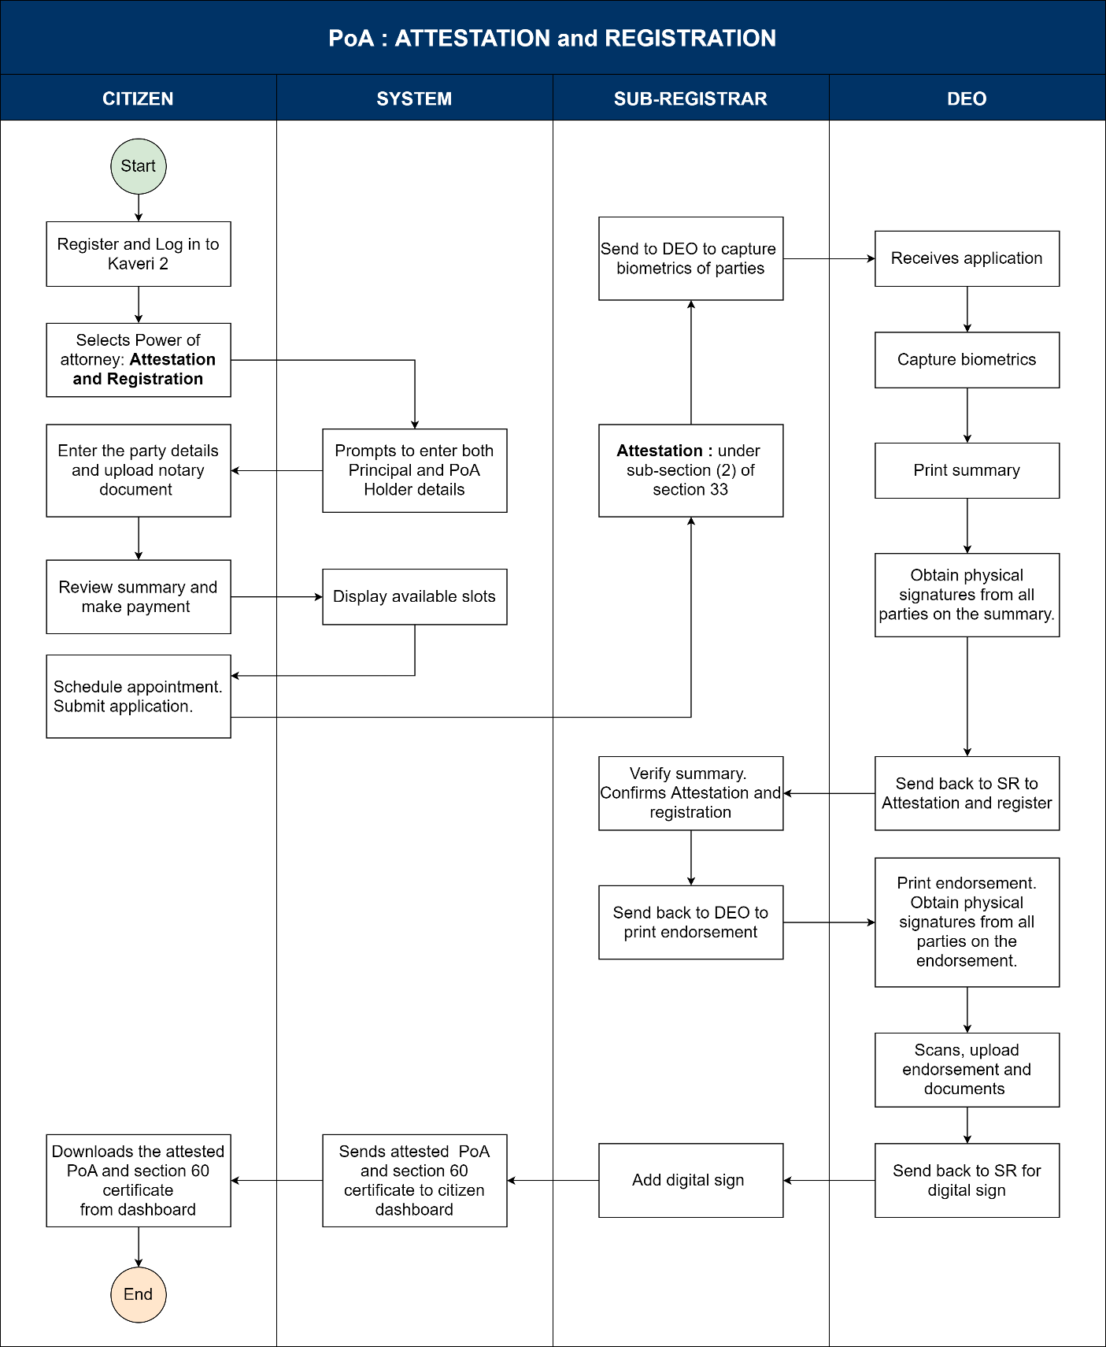
Figure 6: Activity diagram of Power of Attorney Attestation and Registration.
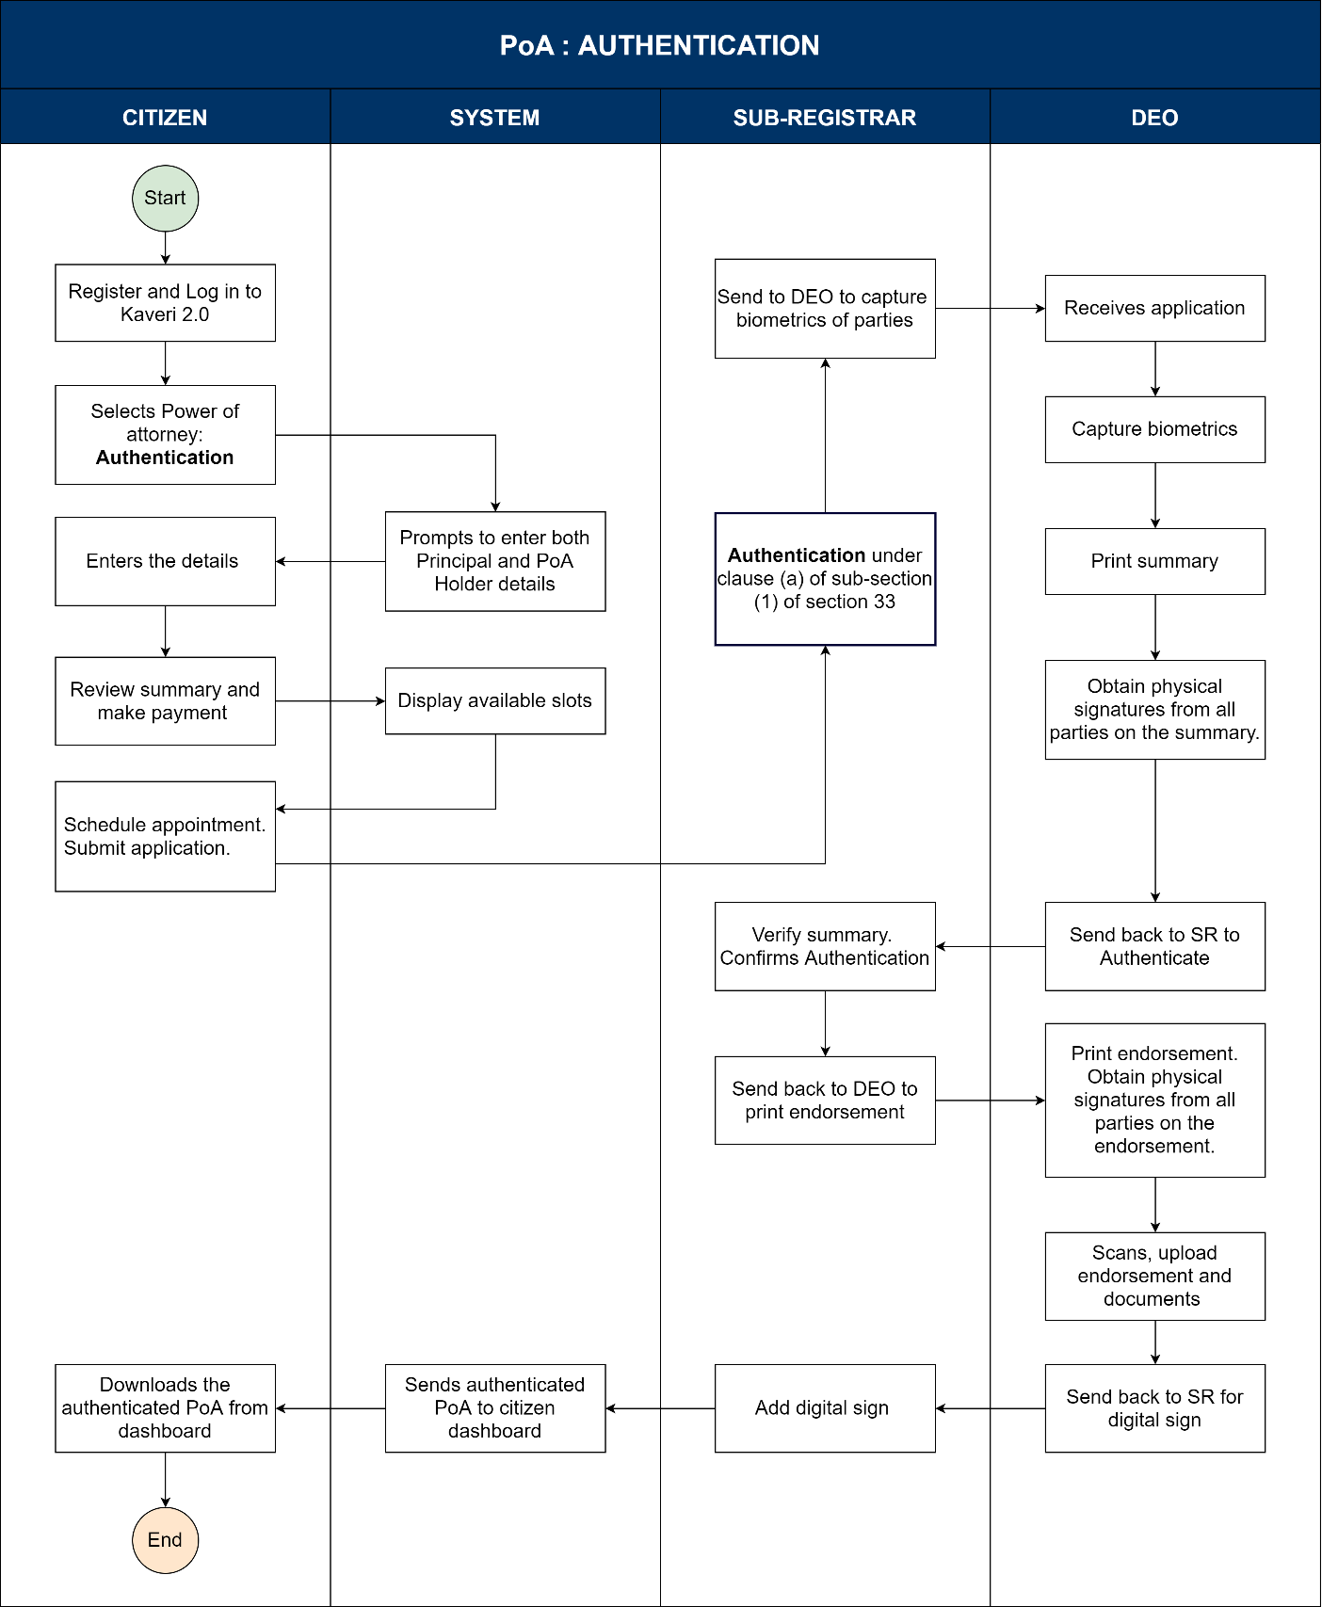
Figure 7: Activity diagram of Power of Attorney Authentication.
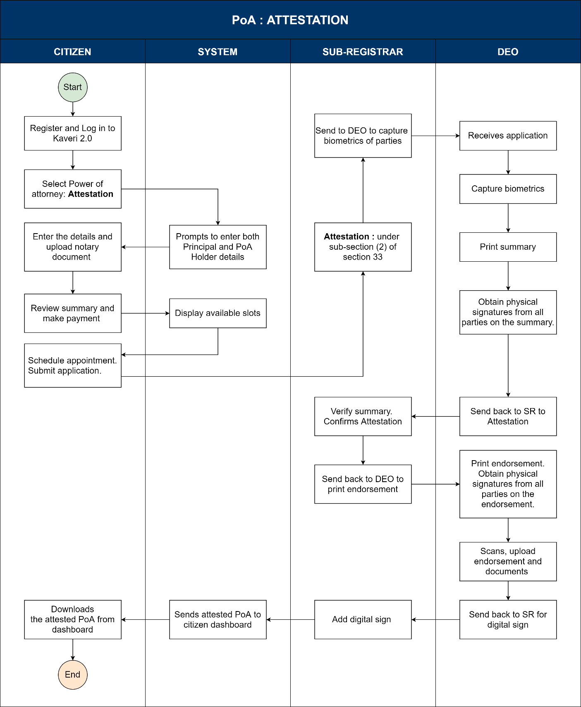
Figure 8: Activity diagram of Power of Attorney Attestation.

Actors and their roles
Functional Requirement Specifications
Stakeholder/ Interface | Role/ Responsibilities
Applicant (Principal) | - Apply for one of the features,  - Authentication and Registration.  - Attestation and Registration.  - Authentication.  - Attestation.
SRO | Kaveri 2 - Jurisdiction SRO  - Receives an application for authentication/attestation and registration or only authentication or attestation.  - Self-verify the details.  - Authenticate/Attest the PoA.  - Approves details by Check and Register  - Allocates to DEO to capture biometrics, scan and upload documents.  - Signs Physically and Digitally the Endorsement received from DEO.
DEO | - Generates endorsements,  - In case of Attestation only a note as per Rule 63(i) to be printed  - In case of Attestation only a note as per Rule 63(ii) to be printed.  - Both Section 60 and Authentication/Attestation Endorsement for Authentication and Registration.  - Take the physical signature of SR on the Endorsement and upload it with other annexures.  - Sends endorsement to SR for Digital sign.
System | - The systems should allow SR to allocate applications to DEO.  - Allows DEO to generate the endorsement.  - Allows SR to digitally sign the endorsement.  - Stores data and reflects as below,  - Authenticated/Attested and Registered applications should appear in Book 1.  - For only Authenticated/Attested applications should be stored in a new book.  - Generates Registration number in case of Authentication/Attestation number and registration.  - Generate Authentication/Attestation number with date in case of only authentication/attestation.
Output documents generated | - Summary  - Form 12  - Endorsement,  - In case of authentication and registration: Section 60 Certificate and Authentication/Attestation note as per section 33 sub-section (1) or sub-section (2).  - In case of only authentication/attestation: Only authentication/ attestation note as per section 33 sub-section (1) or sub-section (2).
Internal changes | - Document Registration module.
Impact on other modules | - MIS

Process Description
- Applicant logs in to Kaveri 2 and applies for Authentication/Attestation of PoA.
Application Process
- Applicant logs in chooses a service option,
  - Authentication and Registration.
  - Attestation and Registration.
  - Authentication.
  - Attestation.
- Fill up the Below details,
  - Party Details (Executant: Principal and Claimant: Agent/Attorney) All the fields are the same as party details of document registration.
  - Description (mandatory text field with a limit of 1000 words) same as description of PoA registration.
- Selection of Presenter: Same as per document registration.
- Identifier details (witness Details) same as per document registration.
- Submit the details for verification of SR.
- Once the document is verified and accepted by SR the citizen should make the payment.
- Makes the payment.
  - Fees are to be calculated as per the below table,
Sl. No. | Type of Fees | Authentication and Registration | Attestation and Registration | Authentication | Attestation
1 | Application Fee | INR 100 | INR 100 | INR 100 | INR 100
2 | Scanning Fee | INR 35/page * No. pages | INR 35/page * No. pages | INR 35/page * No. pages | INR 35/page * No. pages
3 | Stamp Duty | 500 | 500 | 500 | 500
4 | Authentication/ Attestation Fee | 200 | 200 | 200 | 200

- Schedule the appointment.
- Visit SRO on the day of the presentation.

SRO Authentication/Attestation
- On the day of the presentation, the SRO clicks on view application and takes the below steps,
  - Authentication and Registration
    - SRO verifies the documents, verifies the POI of executants and takes the signature of executants on the PoA.
    - Allocate to DEO for Capturing the biometrics and Photos.
    - Checks on Power of attorney are signed before me. (a check box)
    - I am satisfied with the identity of the executor. (a check box)
    - Check and Register the document.
    - Sign Physically DEO uploads Summary, Endorsements as section 60 and Section 33(1) and Annexures.
    - Sign Digitally on the document once the DEO uploads the Summary, Endorsements as Section 60 and Section 33(1) and Annexures.
  - Attestation and Registration
    - SRO verifies the documents, verifies the POI of executants and takes the signature of executants on the PoA.
    - Allocate to DEO for Capturing the biometrics and Photos.
    - I am satisfied with the identity of the executor. (a check box).
    - Check and Register the document.
    - Sign Physically DEO uploads Summary, Endorsements as section 60 and Section 33(2) and Annexures.
    - Sign Digitally on the document once the DEO uploads the Summary, Endorsements as Section 60 and Section 33(2) and Annexures.
  - Authentication
    - SRO verifies the documents, verifies the POI of executants and takes the signature of executants on the PoA.
    - Allocate to DEO for Capturing the biometrics and Photos.
    - Checks on Power of attorney is signed before me. (a check box)
    - I am satisfied with the identity of the executor. (a check box)
    - Check and Register the document
    - Sign Physically DEO uploads Summary, Endorsements as section 60 and Section 33(1) and Annexures.
    - Sign Digitally on the document once the DEO uploads the Summary, Endorsements as Section 33(1) and Annexures.
  - Attestation
    - SRO verifies the documents, verifies the POI of executants and takes the signature of executants on the PoA.
    - Allocate to DEO for Capturing the biometrics and Photos.
    - I am satisfied with the identity of the executor. (a check box).
    - Check and Register the document
    - Sign Physically DEO uploads Summary, Endorsements as section 60 and Section 33(2) and Annexures.
    - Sign Digitally on the document once the DEO uploads the Summary, Endorsements as Section 60 and Section 33(1) and Annexures.
DEO - Allocation
- DEO views the application allocated to him in step 1.
- Captures the biometrics of the executants (Principal).
- Generates the Summary.
- Generated the endorsement based on the nature of the application.
  - Authentication and Registration: Both section 60 and sub-section (1) of section 33 Endorsement.
  - Attestation and Registration: Both section 60 and sub-section (2) of section 33 Endorsement.
  - Authentication: Only sub-section (1) of section 33 endorsement.
  - Attestation: Only sub-section (1) of section 33 endorsement.
- Take the physical signature of SR on Summary, Endorsements and Signature of executants on Summary.
- Upload the signed summary, endorsements and annexure for digital signature.

Prototypes
- You can access the prototype using this link.

Input and Output Validations

Input validations
- Always the principal should be the presenter.
- In case of only attestation/ only authentication biometrics of the principal should be taken.
- In case of Authentication and registration / Attestation and Registration biometrics of all the executants should be collected.

Workflow validations
- Only SR should verify the POA authentication/attestation, allocation to FDA/SDA is not allowed.
- All the authenticated/Attested POAs should have an entry in book 16.
- A form 12 should be generated for all the authenticated/attested POAs along with the endorsement.
- SRO should be able to select and allocate to DEO
- In case of DEO absence or FDA absence, the system should have the provision of in-charge selection.
- The system provides a unique Registration/Authentication or attestation number with the date of the submitted application
- All entries in each book shall be numbered in a consecutive series, which shall commence and terminate with the year, a fresh series being commenced at the beginning of each year.

Integration with other systems/modules

External integration
- No external integration including property registers like Bhoomi, E-Swathu and E- Aasthi.

Internal integration with other modules
- NA

Implications for MIS

Input details
- From Date
- To Date

Output details

Assumptions and Dependencies

Assumptions:
- No J-slip will be sent.
- The PoAs before Kaveri and from Kaveri 1 can be Authenticated/Attested using this module.

Dependencies:
- No dependencies.

Annexures

Annexure – 1 List of modules of Kaveri 2.0
Sl No | Module No | Main Module | Sub-Module
1 | 1.1 | Registration | Registration
2 | 1.2 | Registration | Appointment
3 | 1.3 | Registration | Integration module
4 | 1.4 | Registration | Stamp duty and Registration fee calculation
5 | 1.5 | Registration | Guideline value calculation
6 | 1.6 | Registration | Rule 17 (2) filing
7 | 1.7 | Registration | Rule 17 (3) filing
8 | 1.8 | Registration | Old pending release module
9 | 1.9 | Registration | Re-Registration module
10 | 1.1 | Registration | Will after Death
11 | 1.11 | Registration | Filing documents (FRUITS)
12 | 1.12 | Registration | Scanning
13 | 1.13 | Registration | Memo transmission and filing
14 | 1.14 | Registration | 68(2) correction
15 | 1.15 | Registration | Cross-reference Rule 123
16 | 1.16 | Registration | Integration exemption
17 | 1.17 | Registration | Court entry
18 | 1.18 | Registration | Liability
19 | 1.19 | Registration | Status tracking
20 | 1.2 | Registration | Investigation and Search
21 | 1.21 | Registration | Valuation Module (CVC)
22 | 2 | EC
23 | 3 | CC
24 | 4 | Verify Document
25 | 5 | Power of attorney Authentication Module
26 | 6 | Refund Module
27 | 7.1 | Marriage | Hindu Marriage
28 | 7.2 | Marriage | Special Marriage
29 | 7.3 | Marriage | Special Marriage in Other Forms
30 | 8 | Legacy Record digitisation
31 | 9 | Audit
32 | 10 | Accounts
33 | 11.1 | MIS | Statutory (44)
34 | 11.2 | MIS | Statistical (54)
35 | 11.3 | MIS | Integration (15)
36 | 11.4 | MIS | Computer related (4)
37 | 11.5 | MIS | Reconciliation (5)
38 | 11.6 | MIS | HR (5)
39 | 12.1 | DRO | Firm Registration
40 | 12.2 | DRO | Undervaluation
41 | 12.3 | DRO | Deposit of will
42 | 12.4 | DRO | Adjudication of documents
43 | 13 | IGRO | Appeal
44 | 14 | Master Data Management
45 | 15 | User Management
46 | 16 | Mobile application
47 | 17 | Training Module | Master Trainer, Training Plan

Annexure- 2 Requirements as shared by the department
- Requirements were shared verbally and workflows were verbally approved in August 2023.
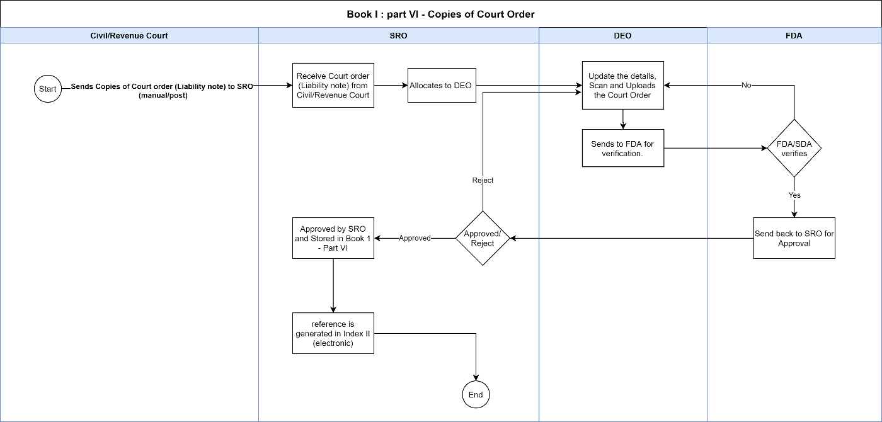

Annexure – 3 Form 12
- Form 12
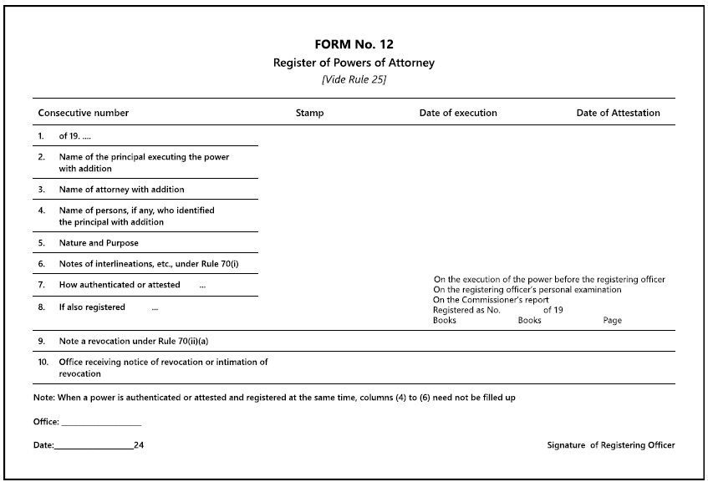

Annexure – 4 Endorsements

- Endorsement under Sub-Section (1) of Section 33: Authentication.
Authentication under clause (a) of sub-section (1) of section 33 of The Registration Act, 1908.

Authentication Number: AUT-XXXXXXXX-XXXXX

Date: ______________

Time: ________________________ SRO: __________________

This Power-of-Attorney has been executed by ________ of _______in my presence on the____ day of____ 20____ The said _____ is personally known to me/the identity of the said ________ has been proved by the testimony of Sri ________ to my satisfaction, and whose signature are affixed to this endorsement.

Signature of the person identifying the principal.

Signature of the (Sub) Registrar
Seal

- Endorsement under Sub-Section (2) of Section 33: Attestation
Authentication under sub-section (2) of section 33 of The Registration Act, 1908.

Authentication Number: ATT-XXXXXXXX-XXXXX

Date: ______________

Time: ________________________ SRO: __________________

This Power-of-Attorney has been voluntarily executed by ________ of _______ I have satisfied myself in this behalf by personal examination of ________ by examination of the said ________ on commission. The said ___________ is personally known to me. The identity of the said ___________ has been proved by the testimony of __________ to my satisfaction, and whose signature is affixed hereunto.

Signature of the person identifying the principal.

Signature of the (Sub) Registrar
Seal
- Endorsement under Sub-Section (2) of Section 33: Attestation + Registration
Authentication under sub-section (2) of section 33 of The Registration Act, 1908.

Authentication Number: ATT-XXXXXXXX-XXXXX

Date: ______________

Time: ________________________ SRO: __________________

This Power-of-Attorney has been voluntarily executed by ________ of _______ I have satisfied myself in this behalf by personal examination of ________ by examination of the said ________ on commission. The said ___________ is personally known to me. The identity of the said ___________ has been proved by the testimony of __________ to my satisfaction, and whose signature is affixed hereunto.

Signature of the person identifying the principal.

Signature of the (Sub) Registrar
Seal
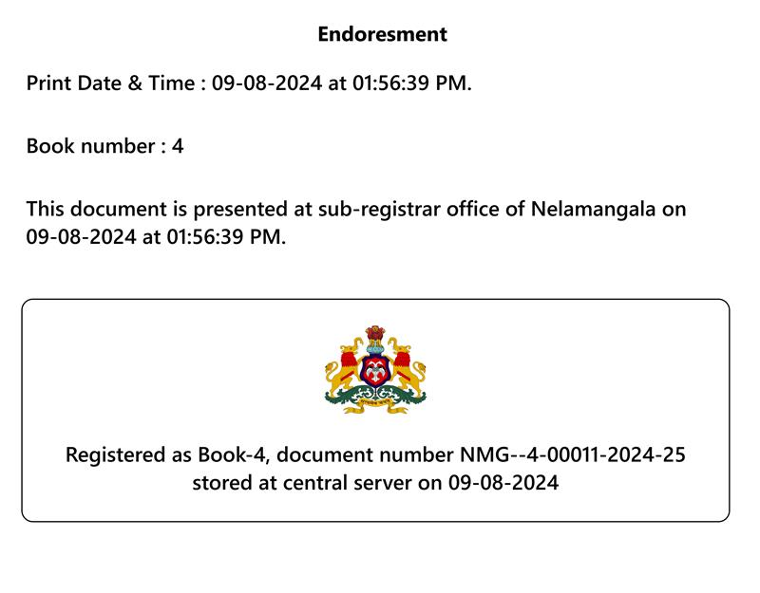
- Endorsement under Sub-Section (2) of Section 33: Authentication + Registration
Authentication under clause (a) of sub-section (i) of section 33 of The Registration Act, 1908.

Authentication Number: AUT-XXXXXXXX-XXXXX

Date: ______________

Time: ________________________ SRO: __________________

This Power-of-Attorney has been executed by ________ of _______in my presence on the____ day of____ 20____ The said _____ is personally known to me/the identity of the said ________ has been proved by the testimony of Sri ________ to my satisfaction, and whose signature are affixed to this endorsement.

Signature of the person identifying the principal.

Signature of the (Sub) Registrar
Seal

Authentication under sub -section (1) of Section 33 as per Karnataka Registration Rules,1965.
Attestation under sub -section (2) of Section 33 as per Karnataka Registration Rules,1965.
As per rule 63(i) of Karnataka Registration Rules, 1965. “When a Power of Attorney is executed before a Registering officer he shall, after satisfying himself og the identity of the party and obtaining when necessary his left thumb impression against the signature, authenticate it. As per rule
As per rule 67 of Karnataka Registration Rules, 1965.
As per rule 63(ii) of Karnataka Registration Rules, 1965. “When a Power of Attorney which has not been executed before a Registering Officer is presented to him for the provisio to section 33 the Registering officer shall, if he attends himself at the private residence of the principal of if the principal appears in the office behind a purdah in case of Ghosha ladies and is examined with help of any witness.”
As per rule 67 of Karnataka Registration Rules, 1965.
As per rule 63(i) of Karnataka Registration Rules, 1965.
As per rule 63(ii) of Karnataka Registration Rules, 1965.

